Quarch Technology Ltd

AN-019

Application Note

HD PPM Calibration

For use with:
HD Power Modules
QTL1999 / QTL1995

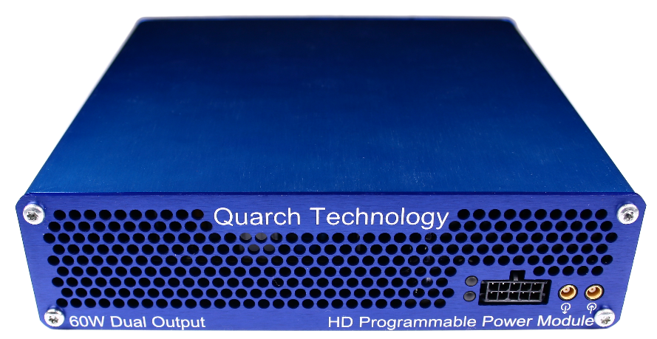

Change History
1.0 | June 2019 | Initial Release
1.1 | August 2019 | Added switch box details
1.2 | March 2020 | Remote switching
1.3 | Oct 2024 | Updated to include Quarch Calibration package

Contents
Change History 2
Introduction 4
WARNING 4
Requirements 5
Installation 6
Equipment Setup 7
Calibration Process 10
Power Module Selection 11
Select Action 11
Select Calibration Instrument 12
Calibration Sections 12
Switch Requests 13
Calibration Output 13

Introduction
Quarch HD power modules may require periodic calibration to ensure they meet the specified accuracy.
While the units have shown very limited change over time, we recommend an annual calibration process.
Calibration is also recommended if a unit is to be used at a temperature significantly outside of the 25C standard ambient level.
Calibration can be performed at Quarch, or via your own (or a 3rd party) calibration lab.
Calibration of a port takes ~10 minutes and produces a calibration certificate including the full results and the data on the Keithley instrument used.
The calibration utility is a simple python script which uses simple console menus to select the device to calibrate. Alternatively, the full details can be passed in as parameters, allowing the calibration to run with no user input.
The calibration utility is designed to be cross-platform, but all current testing and development has been done on a Windows system, so this is the recommended OS for use.

WARNING
The Keithley is a powerful instrument and is capable of driving current and damaging the HD. This will not occur if basic precautions are followed.
- Always follow the calibration instructions fully, starting with both the HD and Keithley turned off.
- In the event of a test crash or unknown state turn the KEITHLEY off before doing anything else. Next power cycle the HD module.
- Do not allow any other process to take control of the HD while the calibration is running.

Requirements
- Windows host PC running python 3.7.x
- Quarch calibration utility (part of the quarchpy package)
- Keithley 2460 source meter
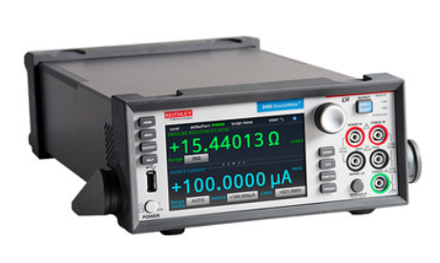
- Calibration switch kit (QTL2294)
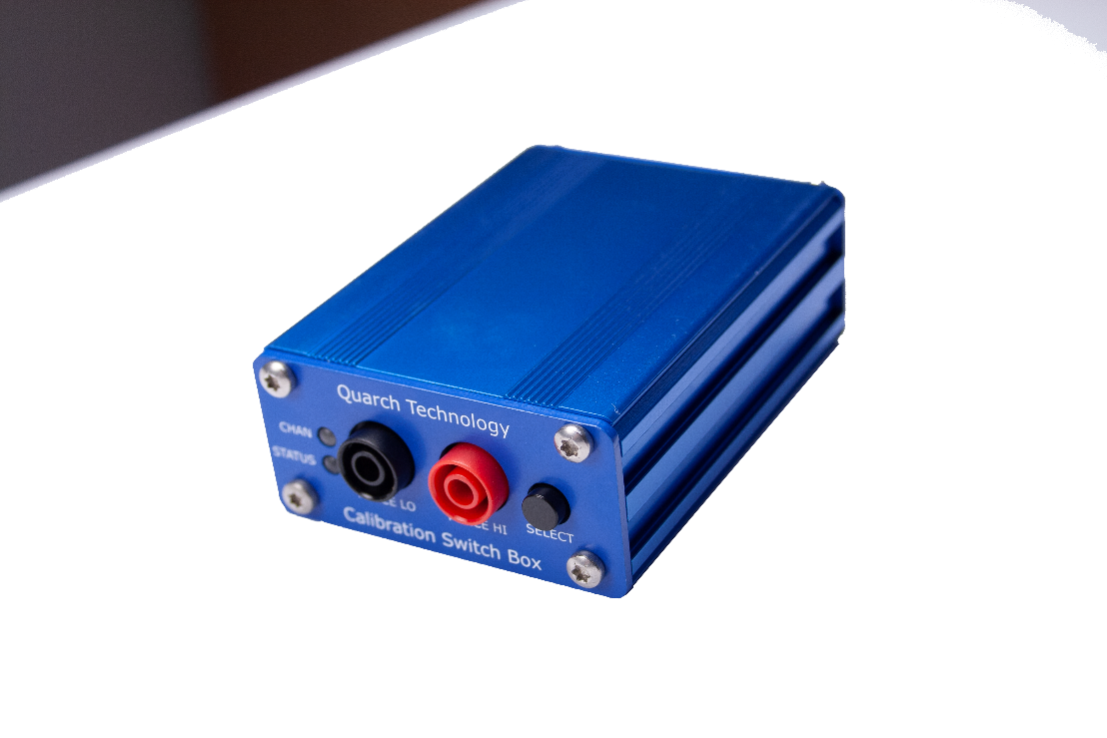

Installation
- Install python 3.13.x
https://www.python.org/downloads/
Ensure the option to add Python to the path is selected
- Install quarchpy and quarchCalibration (Quarch control libraries, and the calibration package) https://pypi.org/user/quarchtech/
- This can be installed automatically via ‘pip’
>python -m pip install quarchpy
>python -m pip install quarchCalibration
- If you already have quarchpy installed, you may need to upgrade it
>python -m pip install quarchpy --upgrade
QuarchCalibration 1.1.11 and Quarchpy 2.2.1 are the latest at the time of writing. Please always use the latest releases of both packages.

Equipment Setup
- Connect the HD power module to mains power
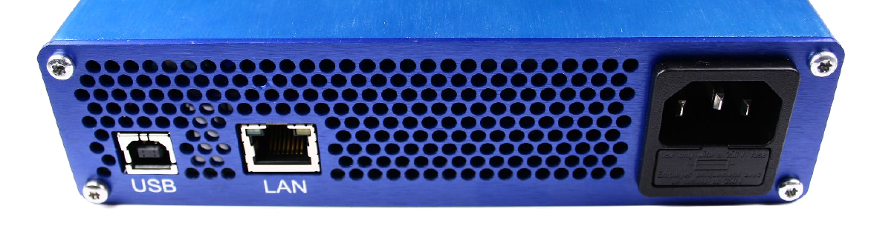

- Connect it on LAN (or USB, for QTL1999 only)


- Attach the calibration kit to the output connector of the HD module with the standard HD output cable
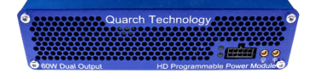

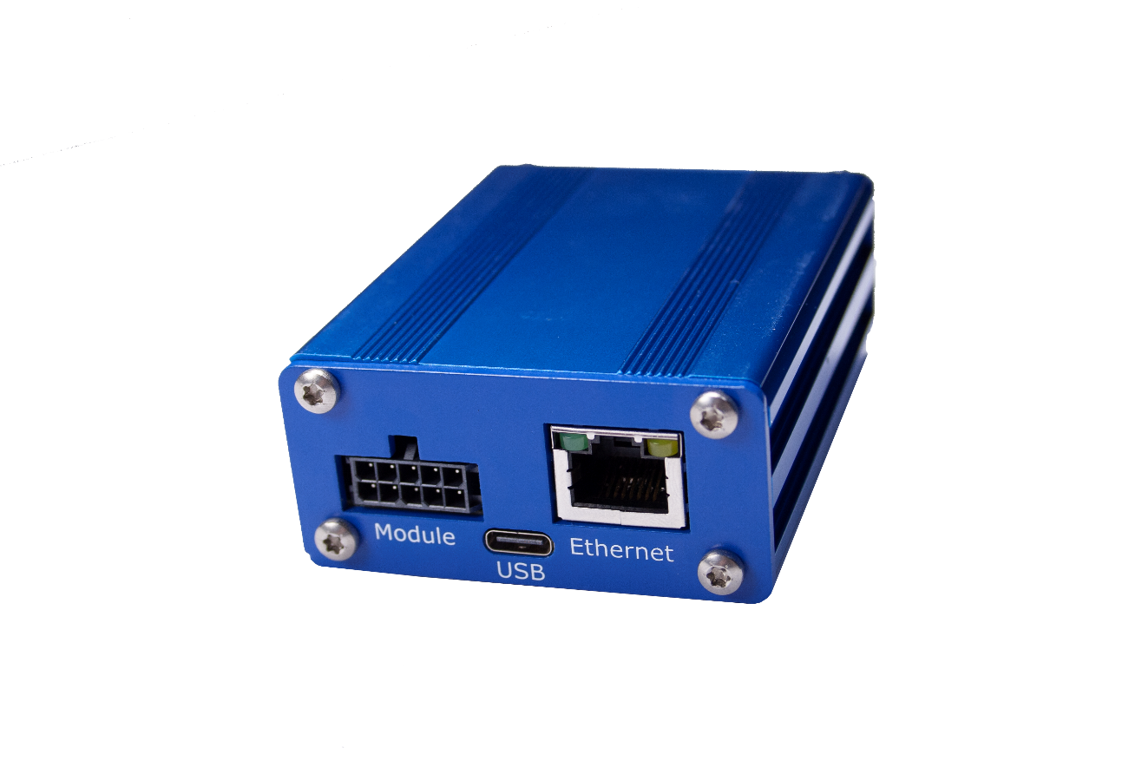

Attach the other end of the HD output cable to the calibration switchbox and connect the switchbox to the network.

- Attach the calibration kit to the Keithley
RED Cable/Connector goes to ‘Force Hi’ Terminal
BLACK Cable/Connector goes to ‘Force Lo’ Terminal

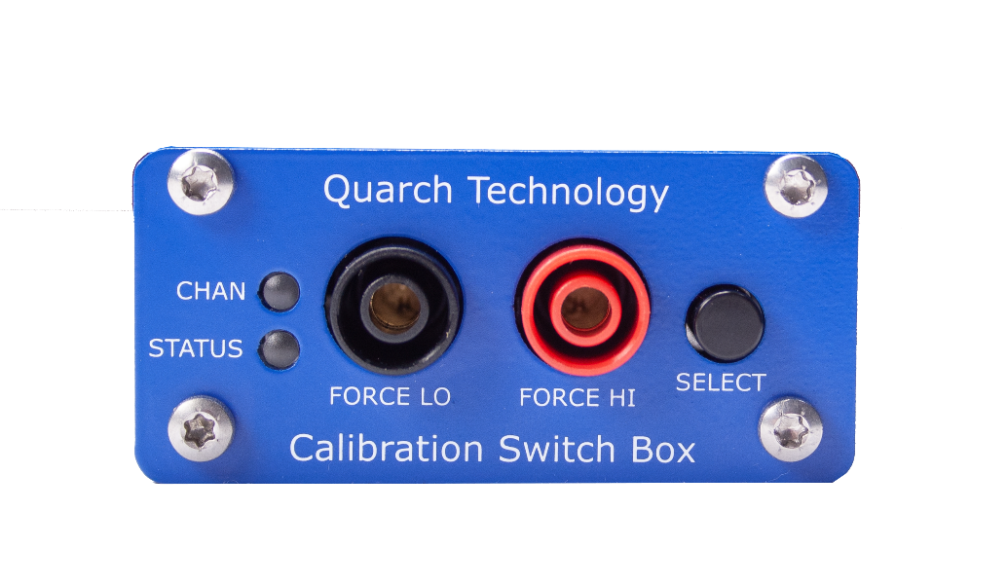
- Connect the Keithley to the LAN and power it up

Calibration Process
The calibration utility can be involved from the command line, or from a python script. Various parameters can be provided but are optional. If a parameter is not provided, the script will query the user to make the selection later. If all necessary parameters are given, no user interaction is required, and the script can run in an entirely automated way.
Calibration can be initiated by command line:
>python -m quarchpy.run calibration
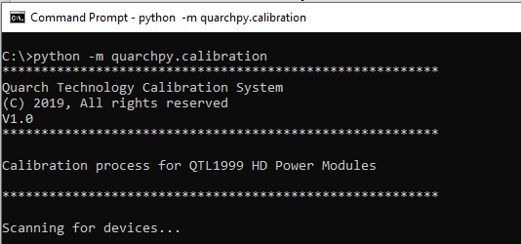
Display the parameter list with the -h option
>python -m quarchpy.run calibration -h
Provide any options you prefer to specify immediately
>python -m quarchpy.run calibration -m TCP:192.168.1.23

Assuming no parameters are given, all options will be requested via user interaction as follows

Power Module Selection
Enter the number of the module you wish to calibrate. Modules are autodetected using a UDP broadcast packet.
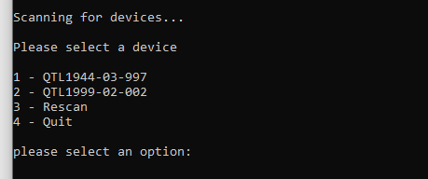

Select Action
Enter the action you wish to run, this menu is displayed after completion of each action
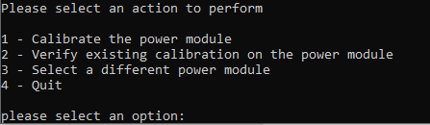
Calibrate Run a full calibration and verification cycle on the module
Verify Run a quick ‘verify only’ of the module to check its calibration is valid
Select Change the power module (allowing to calibrate a new unit)
Quit Exit the utility

Select Calibration Instrument
Enter the action you wish to run, this menu is displayed after completion of each action. Instruments are detected via mDNS.

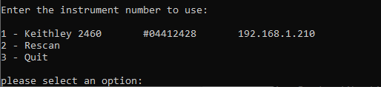

Calibration Sections

Each section of the calibration will display the status. In some cases, the channel will need to be changed to the Keithley instrument. The utility verifies the connection and will not continue until the correct connection is made.
This will generally involve pressing the switch on the calibration switchbox (Unless using LAN controlled version.)

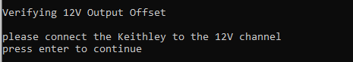

Percentage bars will show you the progress of the calibration section
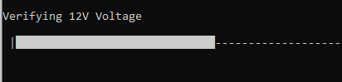
A summary of each section will show you the pass/fail result and the worst case measurement.
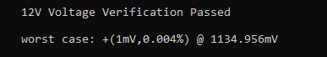
In the event of a failure, a more detailed summary will be shown
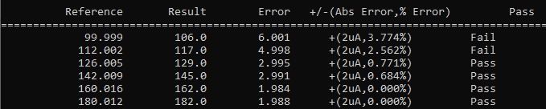

Switch Requests

The calibration switch box (QTL2294) has a button which switches between the two channels which need calibrated. During the process, you will be requested to change channel as required. Simply press the button on the unit. It will click and the upper LED will change color:
Red Connected to 5V channel
Blue Connected to 12V channel
After setting the channel, press enter to continue. The script verifies that the channel is correct before continuing, it will not allow you to make the wrong choice.
If you have a new switchbox QTL2294-02-xxx or higher then this is done automatically.

Calibration Output
As well as the screen details, a file will be produced for each run, in the form:
[SerialNum]_[Date]_[Time]-[Action].txt
QTL1999-02-002_25-06-19_16-01-Calibrate.txt
If a path has not been specified, this will be in the users home folder.
The file contains
- Header showing the details of all parts of the calibration system (serial numbers, version numbers, date/time and similar)
- Full details of every result taken and its pass/fail status
- Overview section with test result, worst case, and overall result

